- News
- Sports
- Opinion
- Obituaries
- Politics
- Arts & Life
- More...
Opinion: Discerning the depths of AI
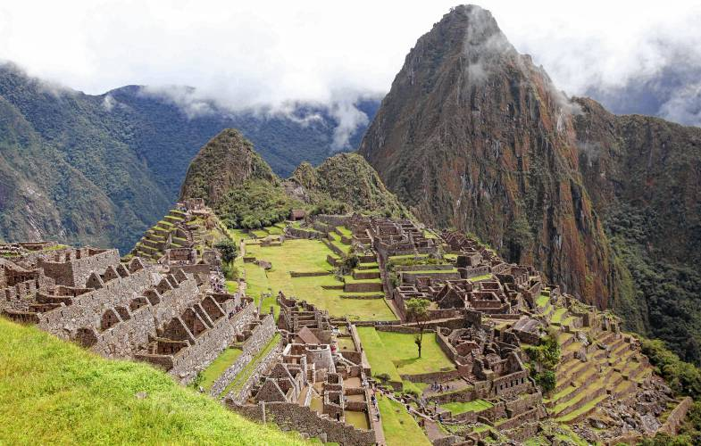
In this April 1, 2010, file photo, the citadel of Machu Picchu is seen during its reopening in Cuzco, Peru. - Karel Navarro/ AP
By STEPHANIE RUTT | Published: 10-12-2023 - 17:00:12
Rev. Dr. Stephanie Rutt is founding minister of the Tree of Life Interfaith Temple in Amherst. She lives in Nashua.
In the October 8th 60 Minute story featuring Geoffrey Hinton, a British computer scientist now called the "Godfather of AI," Hinton reported believing AI could bring enormous benefit to humankind yet also warned that the AI systems may be more intelligent than we know and could even take over. It led me to speculate on what, at least at this point, I'd imagine AI could not do.
I wonder, for example, if it could venture into the Forest of Arden with the banished duke, as in Shakespeare's As You Like It, to find, "tongues in trees, books in running brooks, sermons in stones, and good in everything?"
Would it ever desire to collect rocks as many children and adults do and, just maybe, wonder why? Indigenous folklore tells us stones are the home to the hidden folk, the mythological world of the fairies, gnomes, trolls and forest guardians. It's why British sculptor Andy Goldsworthy says, "There is life in a stone. Any stone that sits in a field or lies on a beach takes on the memory of that place. You can feel that stones have witnessed many things."
The fairies, in particular, have been behind the scenes weaving their magic across time. When the late renowned botanist Dr. George Washington Carver was asked how he could talk to the little flower, he answered, "Through it I talk to the Infinite. And what is the Infinite? It's that still small voice that calls up the fairies."
And the Sami people of Northern Europe believe their joiking, a ritual practice of spontaneous singing engendering a spiritual connection with the whole of life, was a gift from the fairies and elves of the arctic lands.
Will AI be able to converse with the hidden folk or with the Infinite budding flower? Will it be able to sing a love song to the tiny fledging pine, howling woodpecker, or serenade the moon spilling starlight over silent fields of snow?
Will AI be able to hunt with the eagles as 13-year-old Aisholpan Nurgaiv does, a Kazakh girl from Mongolia, who trained to become the first female eagle hunter in twelve generations in her nomad family?
Will AI have the capacity for a love as wide as one like Simone Weil? A well-off secular French Jew, Weil was so affected by what was happening to other, less protected, people under the Third Reich in World War II, she'd decided to live as they lived and died of hunger.
For whom or for what would AI be willing to die?
And what of the mythical hero's journey highlighted by the late Joseph Campbell? You know, the one we humans embark upon when we begin a relationship, start a business, create the next amazing thing, the journey that inevitably brings us to confront what stands in the way of our success, those inner demons and dragons, to, in the end, emerge victorious?
Will AI be able to recognize and slay its own digital dragons?
And though AI may be able to categorize and critically analyze all the great works of art that have ever existed, will it ever be able to stand in front of just one of them and be held breathless, barely able to whisper "ahhhhhh?"
Will AI ever be able to join with others to build a braided bridge? Communities on either side of a canyon in Peru do. Every year, the Q'eswachaka Bridge is rebuilt using traditional techniques since the time of the Incas. The communities gather to weave, tie and haul braided rope to build the bridge that will carry all of them across the canyon. And at the end of three days, there's a grand celebration.
Will AI ever know the feel of rope rubbing across many hot callused fingers?
If we're curious enough to leave behind futuristic possibilities, just for a while, and venture into the Forest of Arden we just might find there what makes us fully human. We may remember that thanking the fish for its life is the greatest blessing, and turn at the apex of danger and beauty, life and death, with wide stretched arms. We just might start to notice the sacred in apples, on the face of the one bagging our groceries, and in the silent communion we feel with those who are suffering.
And before we know it, we just might find ourselves, like the Sami, bursting into song. For we know now we're an integral part of the whole. We're ready now to build a braided bridge and to invite those who live across the canyon, whoever they may be or however they may believe, to join us in building this bridge, one that secures safe passage to all when crossing a great chasm that divides us.
Who knows? Perhaps AI would map the same techniques used by the Inca, or not. No matter. In the Forest of Arden, the real gift would be to sit together and build the bridge, one braid, one tug, one haul, at a time.

